Fabric8

A program package for evaluation of orientation data
and paleostress data,
for strain analysis,
and for analysis
of fold shapes


Paracelsusgasse 59
A-8010 Graz, Austria
e-mail: eckart.wallbrecher@uni-graz.at

1.1 Content of the Package

The program package FABRIC8 consists of the executable program

Fabric8.exe,

and the dll-programs
Further files are:
- LIZENZ.bin (contains the name of the license owner, when the program was bought, or the word ‚Demo’, when the program is tested with a temporary licence.)
- DEUTSCH.txt (contains the text of the German dialogues.)
- ENGLISH.txt (contains the text of the English dialogues.)
- HILFDEUT.txt (contains the text of the German explanations of the button functions.)
- HELPENGL (contains the text of the English explanations of the button functions.)
- FABRIC.ini (saves all settings of the last Fabric8 session.)
- TestConfig.txt (Is used to check the file Fabric.ini for correct spelling and completeness.)

FABRIC8.exe is the program for evaluation of orientation data. Usually the program run without errors, but this does not mean that errors may not arise under conditions which we didn not test. In this case we send a corrected version of the code. Suggestions for improvements are always welcome.

1.2 Hardware-Configuration
The programs run on PCs under Windows 9x, 2000, Windows NT, Windows XP, Vista, or Windows7.

1.3 Improvements since Fabric6
The program Fabric6 has been completely reworked and converted to Windows. The algorithms and graphics are essentially the same.
Many new applications and new programs have been added. Existing programmes have been extended considerably.

1.4 Improvements since Fabric7
Besides many improvements and additions, Fabric8 is compatible to the Windows-Vista help function.

2. Installation
The program can be obtained in two ways:
1) The program can be downloaded from the website ‚geolsoft.com’. The download is in compressed form and must be unzipped with a suitable program.
2) The program is delivered in compressed form on a CD-rom and must be saved in decompressed form in a directory. This is done with the windows installation assistant. Go to the CD-Rom drive and double click on the setup symbol, then follow the installation assistant. Restart the computer after installation.
Attention: If you install the program to a system with read-only restrictions, you have to install the folder FabricIni to an external drive. All drives from A: to Z: are permitted. Do not change or extend the name FabricIni.

3. Application
All parameters of Fabric.ini (Colours, lines, Data-directory etc.) may be changed with a text editor, but it might be better to use the preset parameters and change them during run time. The file „Fabric.ini“ contains the following lines:

Configuration File:
Grafic
Background Colour :,clSilver
Frame Colour :,clBlue
Periphery Colour :,clGray
Diagram Colour :,clWhite
Colour of Data Points :,clBlue
Colour of Great Circles :,clRed
Data Symbol :,FilledDiamond
Line Style :,Solid
Colour of Rose Diagram :,clRed
2nd Diskette :,e
Paths:
C:\Fabric\Data\
c:\Geologische Software\Grafik
Hemisphere :,LOWER
Password :,N
Language :,Deutsch
Statistics
Confidence [%] :,99
Colour of Eigenvectors :,clBlue
Colour of Aperture :,clRed
C. of Cone of Confidence :,clLime
Projection :,Lambert
Colour of Nets :,clBlue
Colour of Equator :,clRed
Background of Diagrams :,$00FFFF80
Colour of Coordinates :,clBlue
1st Contour Line :,$00FF8000
2nd Contour Line :,clYellow
3rd Contour Line :,clBlue
4th Contour Line :,clRed
5th Contour Line :,clFuchsia
Colour of Upper Slip Lines :,clRed
Colour of Lower Slip Lines :,clBlue
Colour of Arrows :,clRed
Formfactor theoretical :,clRed
1st Contour Line :,SOLID
2nd Contour Line :,SOLID
3rd Contour Line :,SOLID
4th Contour Line :,SOLID
5th Contour Line :,Solid
Distance between Contours :,MULTIPLES
1st Contour Line x 10 :,10
2nd Contour Line x 10 :,20
3rd Contour Line x 10 :,40
4th Contour Line x 10 :,60
5th Contour Line x 10 :,120
Counting Calotte x 10 :,10
Multiple of Random (CLODAT):, 2.0
Pooled Group Aperture :,clBlue
Pooled Group C. of Confid. :,clBlack
Paper Plot :,DXF
Paper Size :,DinA4
Format :,Portrait
Colour of Periphery :,clBlack
Radius [mm] :,50
X-Coordinate of Centre [mm]:,60
Y-Coordinate of Centre [mm]:,60
Rose Diagram (Style) :,Block
Rose Diagram (Interval) :,20
Rose Diagram (Increment) :,4
Paleo-Stress Azimut Sigma1 :,142
Paleo-Stress Dip Sigma1 :,25
Paleo-Stress Azimut Sigma3 :,241
Paleo-Stress Dip Sigma3 :,22
Length of Coordinates [mm] :,100
X-Coordin. of Origine [mm] :,20
Y-Coordin. of Origine [mm] :,10
Distance of Circles Deg. :,2
Distance of Points Deg. :,2
Tilt Angle Deg. :,35
Colour of Background :,clSilver
Radius of bitmap [%] :,30
X-Coord. bitmap centre [%] :,5
Y-Coord. bitmap centre [%] :,5
Colour of shearbox objects :,clRED
Colour of sheared objects :,clBLUE
Colour of compression :,clBlue
Colour of extension :,clRed
Symbol of compression :,FilledCircle
Symbol of extension :,FilledCircle
Colour of Polygons :,clSilver
Maximum number of data :,1000
Calibration factor for plot:,2.38
Screen dump calibration :,1
Smoothing factor :,4
Type of Diagram :,Vector
Enlargement (Fry-method) :,10
Colour of ellipse (Fry) :,clRed
Colour of points (Fry) :,clRed
Colour of area (Fry) :,clAqua
Colour of sigma :,clRed
Colour of clicked point :,clLime
Colour of Fourier points :,clRed
Show copyright :,NO
Colour of polygons :,clAqua
Colour of isogons :,clRed
Pen width (in pixel) :,1
1. contour line pen width :,1
2. contour line pen width :,1
3. contour line pen width :,1
4. contour line pen width :,1
5. contour line pen width :,1
Counting grid distance :,12
Colour of foto-lineations :,clWhite
Length of symbols (map) :,20
Percent (Rf/Phi) :,10
Colour of harmonic mean :,clRed
Colour of vector mean :,clBlue
Colour of chi-square back :,$00FFFF80
Colour of chi-coordinates :,clBlue
Colour of chi-graph :,clRed
Brushstyle of ellipse (Fry):,transparent
Save Image Width (Fry-Plot):,1200
Save Image Width (d-Theta) :,1222
Save Image Width (Marker) :,1400
Save Image Width (Stereo) :,1000
Save Image Width (Fourier) :,1222
Save Image Width (Mohr) :,850
Save Image Width (TAlpha) :,700
Save Image Width (Shear) :,2200
Save Image Width (Panozzo) :,1000
Save Image Width (Isogonen):,1000
Save Image Width (Chi-sq.) :,1000
Colour of ellipse (Calcul.):,clBlue
Colour of area (Calculated):,clYellow
Brushstyle of ellipse (Cal):,transparent
Save Image Width (Flinn) :,600
Save Image Width (Hsu) :,600
Colour of iteration curve :,clRed
Font name :,MS Sans Serif
Font size :,8
Font colour :,clWindowText
Font style :,0
Stress vectors :,clRed
Background Mohr :,clSilver
Frame Mohr :,clRed
Coordinates Mohr :,clBlack
Filling Mohr s1 :,$00FFFF80
Filling Mohr s2 :,clLime
Filling Mohr s3 :,clYellow
Background Histogram :,clSilver
Frame Histogram :,clBlue
Coordinates histogram :,clBlue
Filling histogram :,clRed
Save image width (Mohr) :,600
Save image width (Histo) :,600
Top of diagram :,0
Left of diagram :,0
Overlapping :,50
Symbol of radii :,FilledTriangle
Save Image Width (Wellman) :,600

4. The Program FABRIC8

When you start a FABRIC8 session you can choose the language (Fig. 1). The language is saved in ‘Fabric.ini’. All following sessions will be in this language until you change it again.

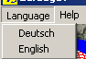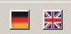
Fig. 1

With the next menu (Fig.2) you fix the position of the graphic form on the screen. The option ‘Position of the first form’ opens Fig. 3 for input of the left and top coordinates of the left upper corner of the form.

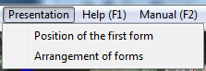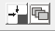
Fig. 2

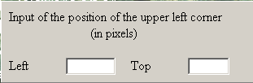
Fig. 3

The option ‘Arrangement of forms’ opens Fig. 4.

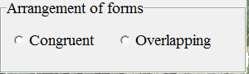 Fig. 4

Here you decide whether all forms are stapled on top of each other (Congruent) or overlapping.

On each form of all subprograms you can call a help function, look into the manual, or open the reference list (Fig. 5).

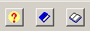
Fig. 5

By clicking on the button „Start“, you open the next form (Fig. 6). By scrolling and double click you choose the program, you want to work with.
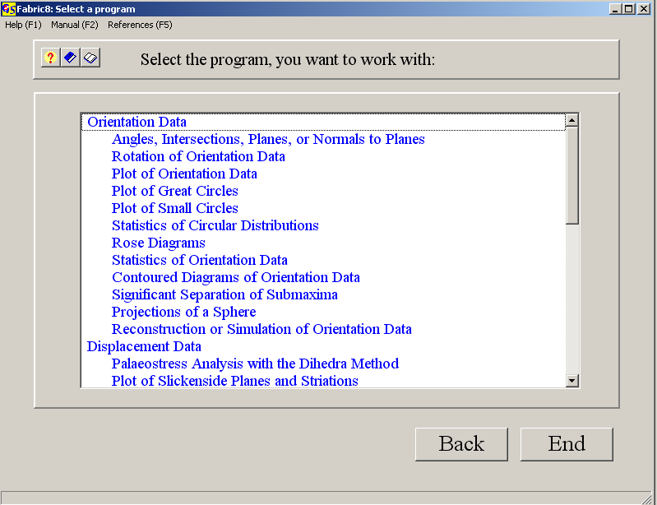
Fig. 5

Fabric8 contains the following programs:
1. CALCULATIONS
2. ROTATION
3. PLOT DATA
4. PLOT GREAT CIRCLES
5. PLOT SMALL CIRCLES
6. CIRCULAR MEASURES
7. ROSE DIAGRAMS
8. FABRIC STATISTICS
9. CONTOUR LINES
10. CLUSTERS OF ORIENTATION DATA
11. PALAEO STRESS
12. PLOT SLICKENSIDES
13. PLOT HOEPPENER-DIAGRAMS
14. SHAPE-FACTOR OF A PALAEO STRESS-ELLIPSOID
15. MOHR’S CIRCLE
16. PROJECTIONS
17. RECONSTRUCTION OF DATA
18. PLOT R%-G%-DIAGRAMM
19. WOODCOCK-DIAGRAMM
20. VOLLMER-DIAGRAMM
21. TEST OF SIGNIFICANCE
22. FOURIER-ANALYSIS OF FOLDS
23. T'ALPHA/ALPHA-PLOT OF FOLDS
24. ISOGONEN
25. SIMULATION OF SHEAR STRAIN
26. FRY METHOD OF MEASURING 2D-STRAIN
27. PROJECTION METHOD OF MEASURING 2D-STRAIN
28. RF/Φ−METHOD OF MEASURING 2D-STRAIN
29. WELLMAN METHOD OF MEASURING 2D-STRAIN
30 FLINN- AND HSÜ-DIAGRAMM for 3D-STRAIN
31. TALBOT METHOD OF MEASURING 3D-STRAIN
32. PLOT DATA INTO A MAP

1 to 10 are used for presentation and statistical evaluation of orientation data which must have the form "azimuth of dip/angle of dip", or "strike/dip dip direction", or data can be readings from a universal stage. The methods for treatment and statistical evaluation of these data are described in detail in WALLBRECHER (1986). For short information see the power point presentation in file “Theory”.
The method of palaeo-stress analysis (11) with compressional dihedra is described by ANGELIER & MECHLER (1977). The Hoeppener-Diagram (13) has been introduced by HOEPPENER (1955). The shape factor of a palaeo-stress ellipsoid (14) is described by WALLBRECHER et al. (1996).
The use of Mohr’s circle (15) is described by MEANS (1976).
The WOODCOCK-Diagram (19) was introduced by WOODCOCK (1977), and the VOLLMER-Diagram (20) by VOLLMER (1990).
The test of significance (21) is programmed after WOODCOCK & NAYLOR (1983).
The programs of these three groups are linked in each group i.e. you can jump from one program to another one in the group by mouse click.
The methods applied in the programs FOURIER (22) und T’ALPHA/ALPHA (23) are taken from RAMSAY & HUBER (1987).
Drawing ISOGONS (24) is described in RAMSAY & HUBER (1987).
SIMULATION OF SHEAR STRAIN (25) is a shear box as explained by RAMSAY & HUBER (1987).
The FRY METHOD (26) is explained in RAMSAY & HUBER (1987).
The "enhanced" Fry method was introduced by ERSLEV (1988).
The PROJECTION METHOD (27) was developed 1984 by Panozzo for strain analysis.
The Rf/φ Method (28) was developed by Lisle (1985) for strain analysis of primary elliptical markers.

The WELLMAN METHOD (29) for twodimensional strain was introduced 1962 by Wellman.
The FLINN and HSÜ DIAGRAMS (30) were introduced FLINN (1962) and by HSÜ (1966).
The TALBOT METHOD Method (31) is described by Talbot (1970) und RAMSAY & HUBER (1987).
The last program (30) enables you to draw a simple structural map from measured data and geographic, Gauss-Krueger-, or UTM-coordinates..
In all programs which require data input, manual input is possible. Data files are in ASCII format. This allows later corrections with a text editor.
Data input from one or more files or directly from an excel sheet is also possible.
Data lists and calculated parameters can also be printed or saved in a *.rtf-file. You can switch during run time between programs which use the same data format.

5. Graphic
The screen resolution should be set to 1024 X 768 pixels.
All screen graphics can be exported as bitmaps into text or graphic files.
*.BMP, *GIF, *.TIF, *.JPG, *.WMF, *.EMF, and *PNG formats can be used.
Vector graphics can also be converted to *.PLT- or *.DXF-files for later treatment with graphic programs as Coral-Draw or Autocad. Direct plot on a colour printer is also possible.

